Research - ICOM 4998 (Final Report)

Solar District Cup

Jeziel E. Torres Vazquez

Email: [jeziel.torres1@upr.edu](mailto:jeziel.torres1@upr.edu)

**Abstract: This report is going to talk about everything done by the Distribution Impact System Analysis for this research.**

**1 Introduction**

This research started for me in January, it was something new for me because it was my first professional work done with a team of engineering students. For this final report I’m going to talk about everything me and the Distribution Impact System Analysis did to accomplish the goal of winning first place in the Solar District Cup. It was a magnificent experience and I would gladly participate again.

**2 Work done**

The Distribution Impact System Analysis is an important part of an electric system. This report checked and simulated all the components working together before connecting them. This helps a lot to check if the components are compatible and will work fine without any repercussion or trouble. For this The team was assigned to use a software that could connect and simulated them working for a full year. This software is called OpenDss.

With this software the process was much easier. All the components could be programmed and mesure at once. The transformer, Solar Panels, Battery and inverter were programmed in the software. This required the technical data so the voltages and connections where correct. For this the team watched videos tutorials offered from the competition organizers. This helps a lot to understand how OpenDss works and start with the simulations right away.

These tutorials were posted by the competition in HeeatSpring, the official resources site for the competitions teams. The videos were explained by Dr. Latif who is an expert in the area and with simulation software. Dr. Latif explained what was the distribution impact analysis and how it would help the team for a better and more stable system. The team learned a lot on how to write the code for the solar panels, battery and transformer. With all of this information the team was ready to start coding and making the connections needed.

First the team focuses on connecting the solar panel to their respected transformer. This was made because it will reduce the load for the transformer and is better practice since each building already had their own transformer. Then the connections for the monitors were made. This helps to measure and check how the system is working and if anything is causing problems.

There were monitors for the transformer, solar panels arrays and batteries. This helped the team to check if all the connections were made correctly and supervised anything that could go wrong. The monitors used were: Voltage Vs Time, Active and Reactive Power, Heat Map and Voltage Vs Distance. All of these monitors made a better system because everything was measured and checked constantly.

After this we had to wait some time to get the real data from the design team. With this time the team tries to anticipate any complications and study some of the more typical errors. This was made to ensure faster corrections and less delay at the time something went wrong. This helps to understand better the simulation and the code, components and connections that were made. When the design team gave us the data, some overloads and overvoltages occurred, but were corrected in little time.

With all of this done, the team leader asked me if I could help with the decision and targeting the perfect Solar Panel Mount for the system. This task was to work together with Angel Figueroa. We did constant meeting and research to find the best mount for the system needs. Some of the considerations were: tilt, permisology, resistance to snow load and wind load. With all this research we started looking and found the best mount for the solar panels.

With this done, the only thing left was to start the final report for the judges to deliberate. This was done in the last two weeks. The Distribution Impact System Analysis searches for all the references, data, code and papers that were used to complete the full analysis. Also all the code explaining and logic were presented in the report. Graphs, monitors and maps were presented to make a better report and easier for the reader. With all of this done the final presentation day arrived and the UPRM Team were victorious.

**3 Graphs, tables, and picture**

Here are some of the graphs use for the final report:

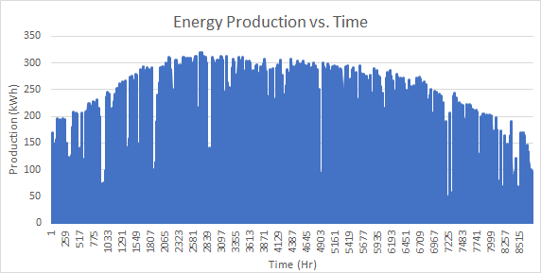

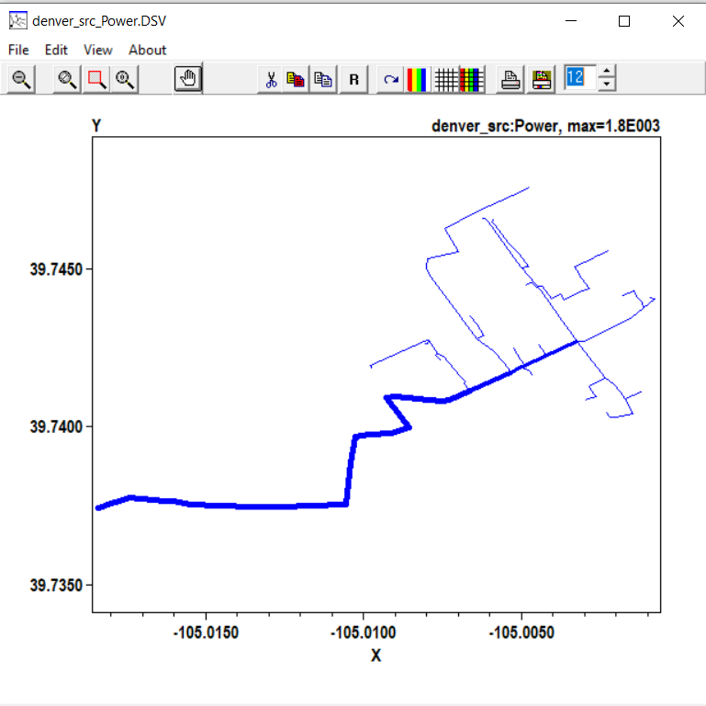

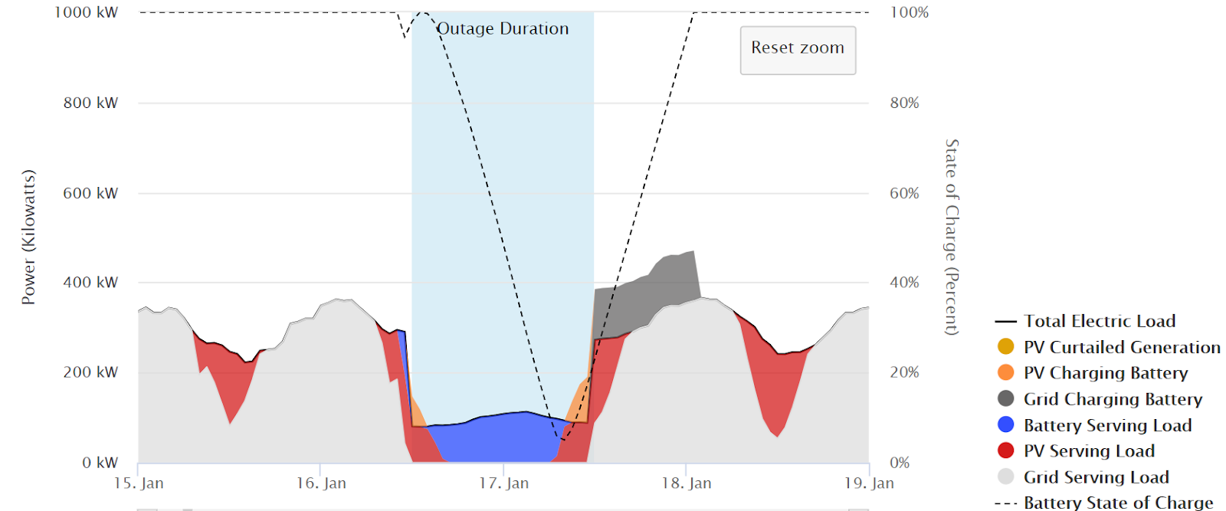

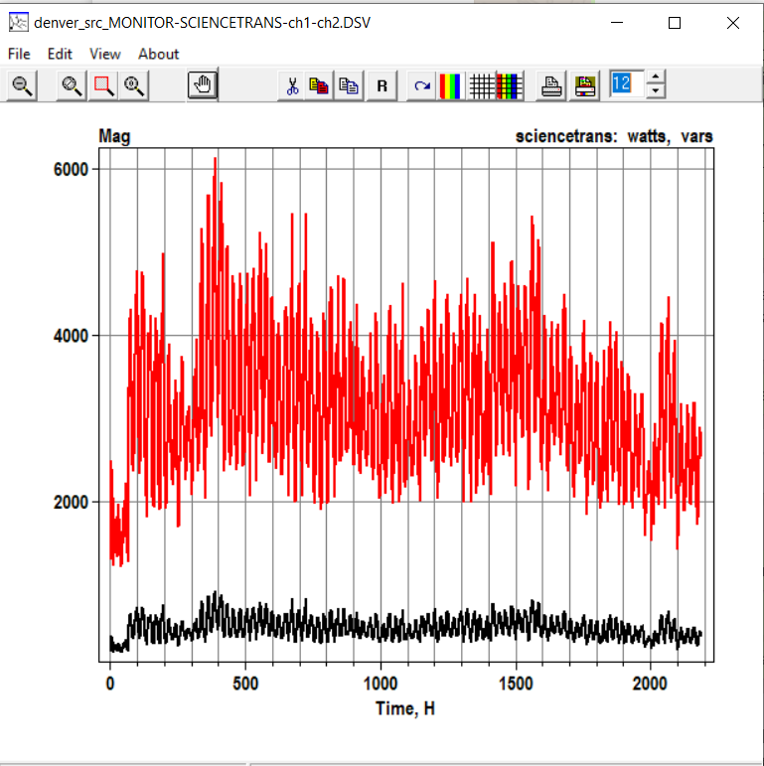

**4 Conclusion**

This experience was a rewarding one. The teamwork was excellent and all the reports worked perfectly. I learned a lot from solar systems, batteries, PV mounted and more. The Distribution Impact System Analysis is one of the more importants parts because all the design could be perfect but if it doesn't work well together then you would have a imcompeted system. The team worked perfectly and I learned a lot from all my team members. I am very happy that the team gave this opportunity and the professor Dr. Eduardo Ortiz accepted me in this research. I will never forget this experience and will always remember the great work that was done.